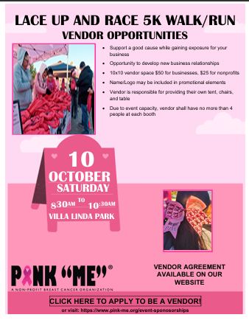

Company/Organization Name: ___________________________________________________________
Mailing Address: City: _________________________ State: ______________ Zip: _________________ Phone: _________________________ Email: __________________________________________________
Name(s) of Vendor Personnel: _____________________________________________________________
Please see accompanying vendor information for event specifics and deadlines.

PINK “ME” ® 4th Annual Lace Up and Race 5K Walk/Run
Saturday, October 10, 2026, Villa Linda Park in Santa Fe, NM from 8:30AM - 10:30AM


VENDOR AGREEMENT
A single vendor space (at least 10x10) is $50 for businesses and $25 for
nonprofits.
After August 30, if there are still vendor spaces available, there will be an additional $50 charge
($100).
Vendors must complete full registration with payment by Aug 31st to be eligible to participate.
We accept checks, cards, or money orders. Please make payable to “PINK “ME”
Please mail or email this commitment application and payment in full based on above rates to:
PINK “ME”
7820 Enchanted Hills Blvd STE 252
Rio Rancho, NM 87114
Or you may email to: info@pink-me.org

____________________________________________________ ______________
Signature Date
_____________________________________________________________________________________
Print Name
Vendor Information
Vendor Space: Vendors are on a first come first serve basis, and all vendors are responsible for
providing their own tables, cords, chairs, and other supplies and equipment.
There is a 10-vendor
maximum.
Vendor Set Up/Tear Down: Set up will be 7:00AM -8:00AM the day of the event. Planned event
hours: 8:00AM – 11:00AM. Tear down must be completed no later than 11:30AM on the day of
the event.
Event Hours: All event hours are from 7:00AM – 11:00AM MST.
Questions? Please email: info@pink-me.org

