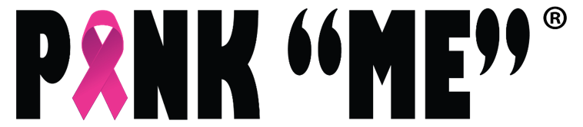
If you are passionate about helping women and families through breast cancer treatment, here are ways to support!

No event is too big or too small, please email us to inquiry about creating own fundraiser. Members of our community have held birthday fundraisers, fundraisers for service projects, baking fundraisers, popcorn fundraisers and more. We’d love to hear your creative ideas, to help support our mission to compassionately support women during and after their breast cancer journey through education, inspiration, and advocacy, so they lead healthy fulfilled lives within a supportive community.

FREQUENTLY ASKED QUESTIONS
Once I apply, how long do I have to wait to find out if my event is approved?
Please allow 2 weeks for a response.
Will PINK “ME” supply any marketing materials for fundraisers?
No, due to limited resources, PINK “ME” does not supply materials for fundraisers.
Can I use the PINK “ME” name and logo?
Yes! You may include that you are fundraising ”to benefit PINK “ME”.
We would be thrilled to see our logo on any collateral you create (website, flyers, social media, etc.). Once approved, we will send you a link to the official PINK “ME” logo. We require that our logo is a minimum of 50% smaller than your name or logo. Thank you!
Will someone from Pink Aid be present at my event?
We will do everything we can to help make your event a success. We can promote on our social media platforms, including Facebook and Instagram, and we can advise your group with ideas and best practices. (Due to our limited resources, we can’t guarantee attendance.)
Do I need to be a non-profit 501(c)(3) to host an event?
No, anyone can host a fundraiser!
Will Pink Aid reimburse me for expenses?
Unfortunately, PINK “ME” cannot reimburse expenses.

